SOLUTIONS PART A – MATHEMATICAL INDUCTION INVESTIGATION

1. Required to prove 1² + 2² +…+n² = 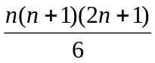 for all positive integers n..
Step 1 Verify the statement is true when n = 1
L.H.S.= 1
R.H.S. = 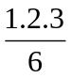 = 1
Statement is true for n = 1

Step 2 Assume the statement is true for n = k
That is, 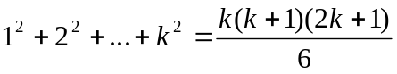

Step 3 Prove statement true for n = k + 1
That is, prove 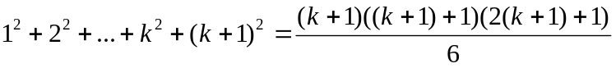
LHS = 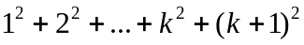
= 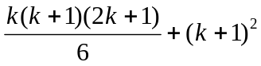 from Step 2
=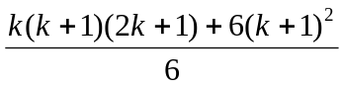
=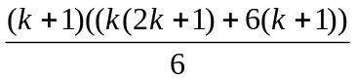
=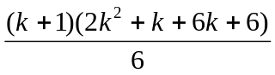
=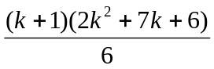
=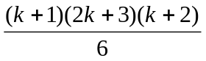
=
=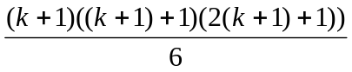
=RHS

The statement is true for n = k + 1 if it is true for n = k.

Step 4 As the statement is true for n = 1 it must be true for n =2.
As the statement is true for n = 2 it must be true for n =3 and so on.

Hence, 1² + 2² +…+n² = is true for all positive integers n.

2. Required to prove 1³ + 2³ +…+n³ = 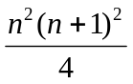 for all positive integers n.
Step 1 Verify the statement is true when n = 1
L.H.S.= 1
R.H.S. = 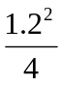 = 1
Statement is true for n = 1

Step 2 Assume the statement is true for n = k
That is, 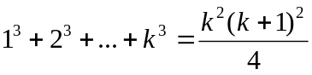

Step 3 Prove statement true for n = k + 1
That is, prove 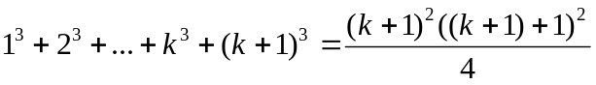
LHS = 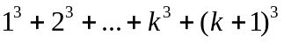
= 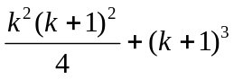 from Step 2
=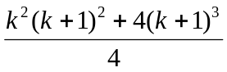
=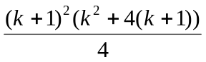
=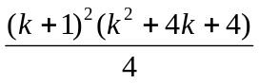
=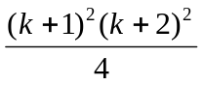
=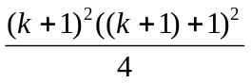
=RHS

The statement is true for n = k + 1 if it is true for n = k.

Step 4 As the statement is true for n = 1 it must be true for n =2.
As the statement is true for n = 2 it must be true for n =3 and so on.

Hence, 1³ + 2³ +…+n³ = is true for all positive integers n.

- Required to prove 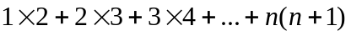 = 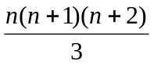 for all positive integers n.

Step 1 Verify the statement is true when n = 1
L.H.S.= 2
R.H.S. = 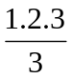 = 2
Statement is true for n = 1

Step 2 Assume the statement is true for n = k
That is, 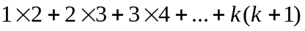 = 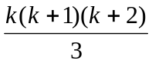

Step 3 Prove statement true for n = k + 1
That is, prove =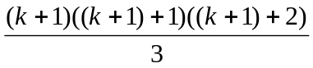
LHS =
= + 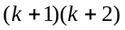 from Step 2
=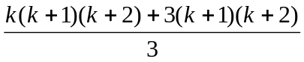
=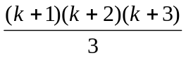
=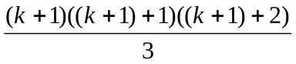

=RHS

The statement is true for n = k + 1 if it is true for n = k.

Step 4 As the statement is true for n = 1 it must be true for n =2.
As the statement is true for n = 2 it must be true for n =3 and so on.

Hence, = is true for all positive integers n.

4. Required to prove 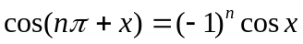for all positive integers n.

Step 1 Verify the statement is true when n = 1
L.H.S = 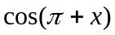
= 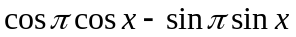
= 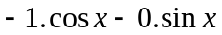
=
R.H.S. = 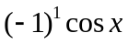
=

Statement is true for n = 1

Step 2 Assume the statement is true for n = k
That is, 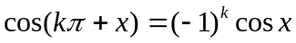

Step 3 Prove statement true for n = k + 1
That is, prove 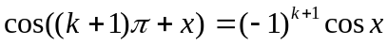
LHS = 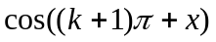
=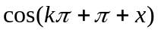
=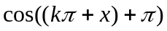
=
=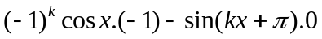 from Step 2
=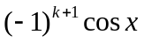
=RHS

The statement is true for n = k + 1 if it is true for n = k.

Step 4 As the statement is true for n = 1 it must be true for n =2.
As the statement is true for n = 2 it must be true for n =3 and so on.

Hence, is true for all positive integers n.

5. Required to prove 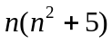 is divisible by 6 for all positive integers n.

Step 1 Verify the statement is true when n = 1
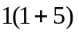 = 6
Divisible by 6
Statement is true for n = 1

Step 2 Assume the statement is true for n = k
That is, 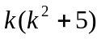 is divisible by 6

Step 3 Prove statement true for n = k + 1
That is, prove 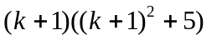 is divisible by 6

= 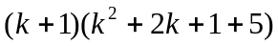
=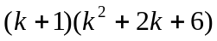
=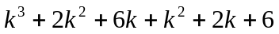
=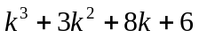
=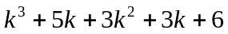
=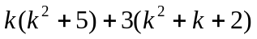

is divisible by 6 from Step 2

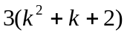 is divisible by 6 if 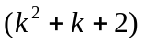 is even
If is an odd number 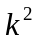 is odd so = odd + odd +2 = even
If is an even number is even so = even + even +2 = even
So is even for all positive integers so is divisible by 6
is divisible by 6

The statement is true for n = k + 1 if it is true for n = k.

Step 4 As the statement is true for n = 1 it must be true for n =2.
As the statement is true for n = 2 it must be true for n =3 and so on.

Hence, is divisible by 6 is true for all positive integers n.

- Required to prove that the nth derivative of 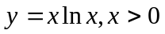 is 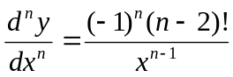for all positive integers n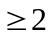.

Step 1 Verify the statement is true when n = 2
L.H.S. 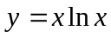
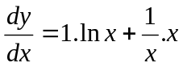
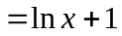
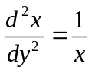
R.H.S. = 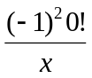=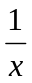=LHS
Statement is true for n = 2

Step 2 Assume the statement is true for n = k
That is, 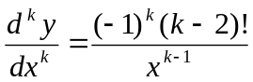

Step 3 Prove statement true for n = k + 1
That is, prove 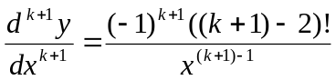
LHS = 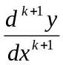
= 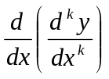
=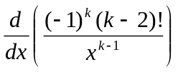 from Step 2
=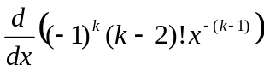
=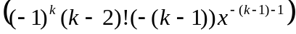
=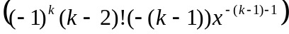
=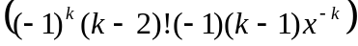
=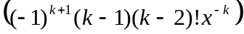
=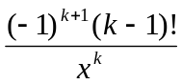
=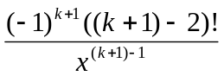
=RHS

The statement is true for n = k + 1 if it is true for n = k.

Step 4 As the statement is true for n = 2 it must be true for n =3.
As the statement is true for n = 3 it must be true for n =4 and so on.

Hence, the nth derivative of is for all positive integers n.
7.

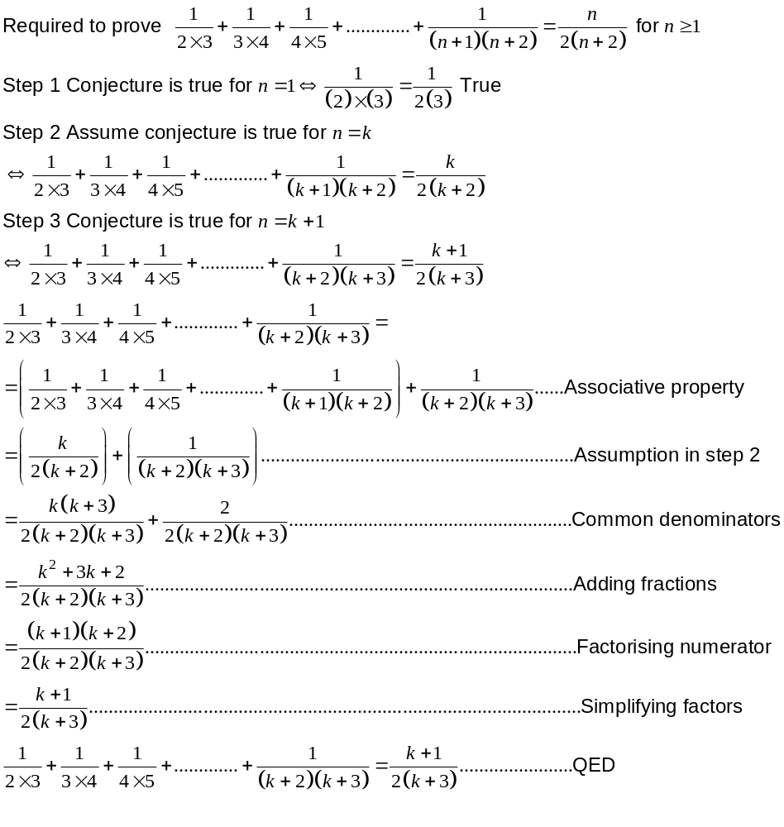
Step 4 As the statement is true for n = 1 it must be true for n =2.
As the statement is true for n = 2 it must be true for n =3 and so on.

Hence 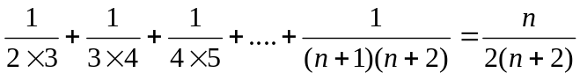 is true for all positive integers n.

